CYBERSECURITY MINI PROJECT
MESSAGE ENCRYPTION IMPLEMENTATION USING CYBERCHEF
Prepared By
SAMUEL OCHOCHE PETER
Cybersecurity Student
3MTT Cybersecurity Program

ABSTRACT
Cryptography is a fundamental component of modern cybersecurity that protects sensitive information from unauthorized access. This project demonstrates the practical implementation of message encryption and decryption using CyberChef, a web-based data transformation and cryptographic analysis tool developed by GCHQ. The project focuses on the use of the Advanced Encryption Standard (AES) algorithm to transform readable plaintext into unreadable ciphertext and subsequently restore the original message through decryption. This exercise provides practical experience in data confidentiality, symmetric encryption, key management, and secure communication principles.

- INTRODUCTION
As organizations increasingly rely on digital communication and electronic data storage, protecting sensitive information has become a critical cybersecurity requirement. Encryption is one of the most effective techniques used to safeguard information from unauthorized access.
Encryption converts readable information known as plaintext into an unreadable format called ciphertext. Only authorized users possessing the correct cryptographic key can decrypt and recover the original information.
This project uses CyberChef to implement encryption and decryption processes using the AES algorithm. The project demonstrates how encryption protects data confidentiality during storage and transmission while emphasizing the importance of proper key management.

- PROJECT OBJECTIVES
The objectives of this project are:
• Understand the concepts of encryption and decryption. • Gain practical experience using CyberChef. • Implement symmetric encryption using AES. • Configure encryption parameters including keys and Initialization Vectors (IVs). • Generate ciphertext from plaintext data. • Successfully decrypt ciphertext to recover the original message. • Understand the importance of cryptographic key management. • Learn the difference between plaintext and ciphertext.

- OVERVIEW OF CRYPTOGRAPHY
Cryptography is the science of protecting information through mathematical techniques that transform data into secure formats.
Key cryptographic concepts include:
Plaintext
Plaintext is readable information before encryption.
Example:
Confidential Company Data
Ciphertext
Ciphertext is encrypted information that appears unreadable to unauthorized users.
Example:
86bc642395a0e39032b3c222bfde2a64841519e2c20803890219ed6b591a13fd
Encryption
Encryption converts plaintext into ciphertext using an algorithm and cryptographic key.
Decryption
Decryption converts ciphertext back into plaintext using the same key and encryption parameters.

- ADVANCED ENCRYPTION STANDARD (AES)
The encryption algorithm selected for this project is the Advanced Encryption Standard (AES).
AES is one of the most widely used symmetric encryption algorithms in the world and is trusted by governments, financial institutions, cloud service providers, and security professionals.
Features of AES include:
• Strong cryptographic security • Fast encryption and decryption performance • Industry-wide adoption • Protection against brute-force attacks when strong keys are used
Applications of AES include:
• Secure web communications • VPN technologies • Database encryption • Cloud storage security • Financial transactions • Government communications

- CYBERCHEF ENVIRONMENT SETUP
CyberChef is a web-based toolkit designed for data transformation, encoding, decoding, encryption, decryption, and forensic analysis.
The CyberChef interface consists of:
• Operations Panel • Recipe Configuration Area • Input Panel • Output Panel
Figure 1: CyberChef Interface
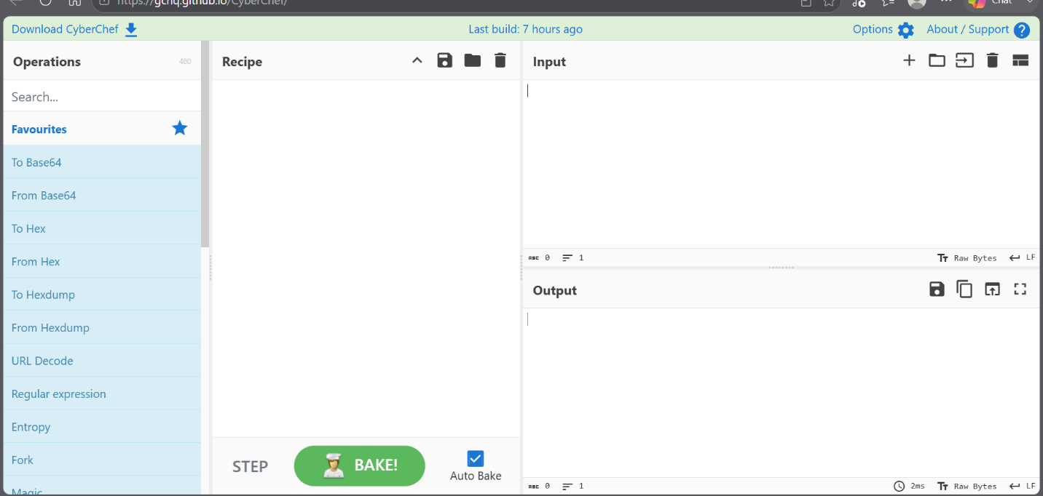Analysis
The CyberChef environment was successfully accessed and configured for encryption and decryption operations.

- AES ENCRYPTION IMPLEMENTATION
The plaintext message used for this project was:
Confidential Company Data
AES encryption was selected and configured using the following parameters:
Encryption Algorithm: AES
Mode: CBC (Cipher Block Chaining)
Key Format: UTF-8
Initialization Vector (IV): Configured
Encryption Key: Configured Secure Key
Figure 2: AES-256 Encryption Configuration
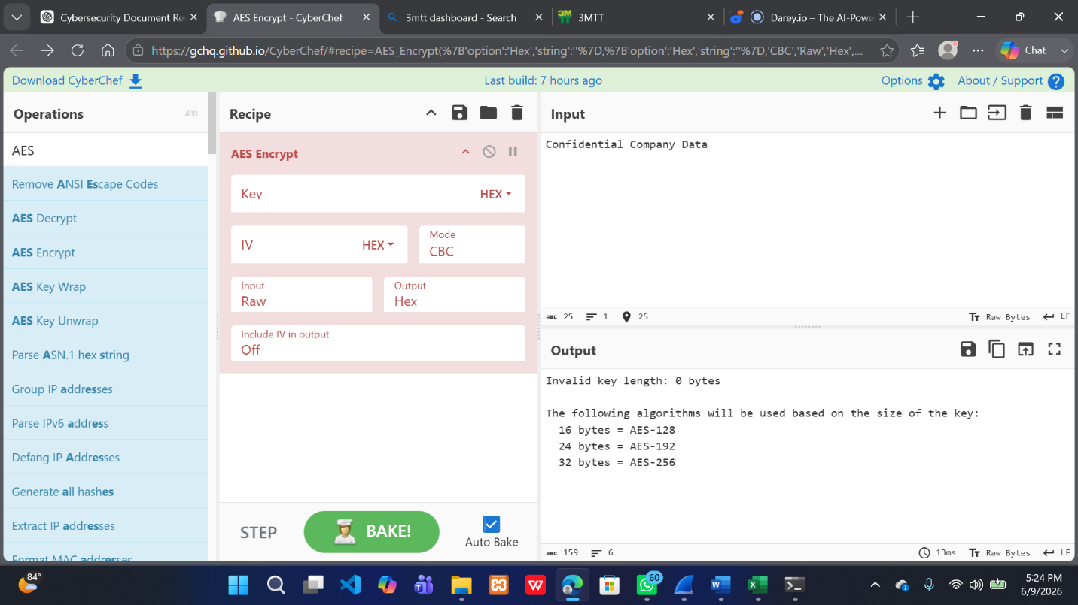Analysis
The AES encryption operation was successfully configured using a symmetric cryptographic key and initialization vector. These parameters ensure that the same plaintext will generate a secure encrypted output while maintaining confidentiality.

- GENERATED CIPHERTEXT
After applying the AES encryption operation, the plaintext was transformed into ciphertext.
Figure 3: Generated Ciphertext
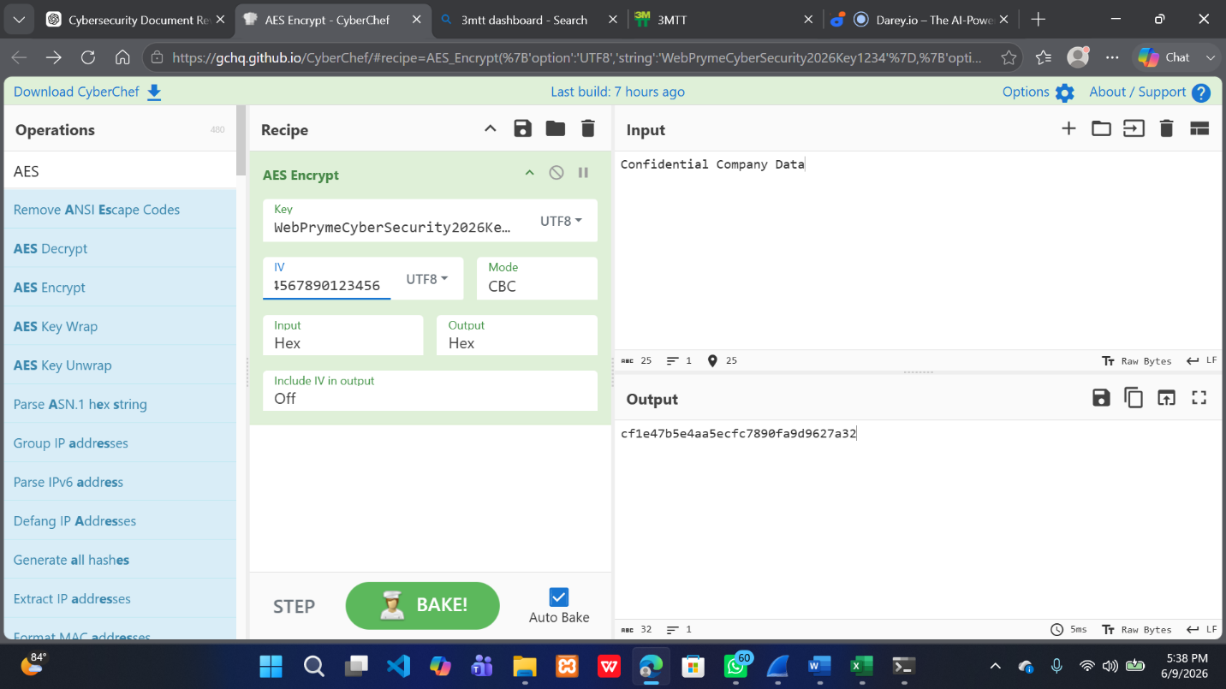
Analysis
The resulting ciphertext appears as unreadable data and cannot be interpreted without the correct cryptographic key and initialization vector. This demonstrates the effectiveness of encryption in protecting sensitive information.
Security Benefit
Even if an attacker intercepts the encrypted data, the information remains protected unless the correct key and parameters are known.

- AES DECRYPTION IMPLEMENTATION
To restore the original message, the AES Decrypt operation was configured using the same parameters used during encryption.
The following were reused:
• Encryption Key • Initialization Vector (IV) • AES Algorithm • CBC Mode
Figure 4: AES Decryption Configuration
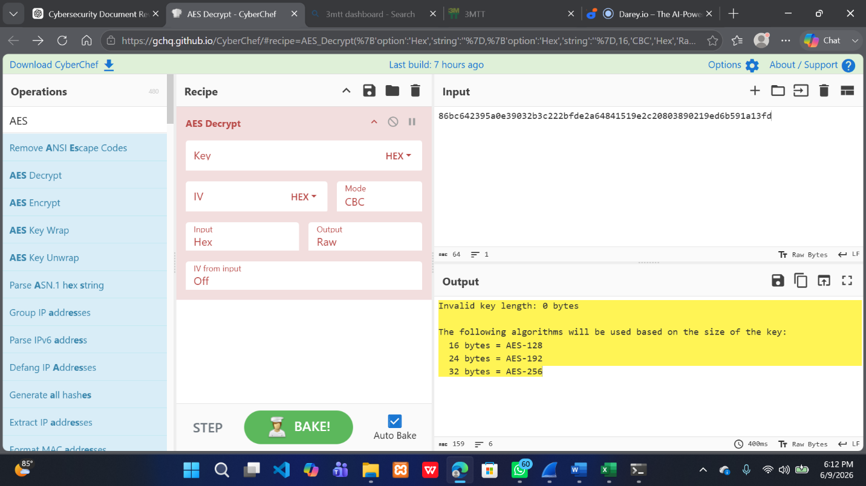Analysis
Successful decryption requires the exact same cryptographic settings used during encryption. Any modification to the key, IV, or mode would result in decryption failure.

- SUCCESSFUL MESSAGE DECRYPTION
The ciphertext was successfully decrypted back to its original plaintext form.
Recovered Plaintext:
Confidential Company Data
Figure 5: Successful Message Decryption
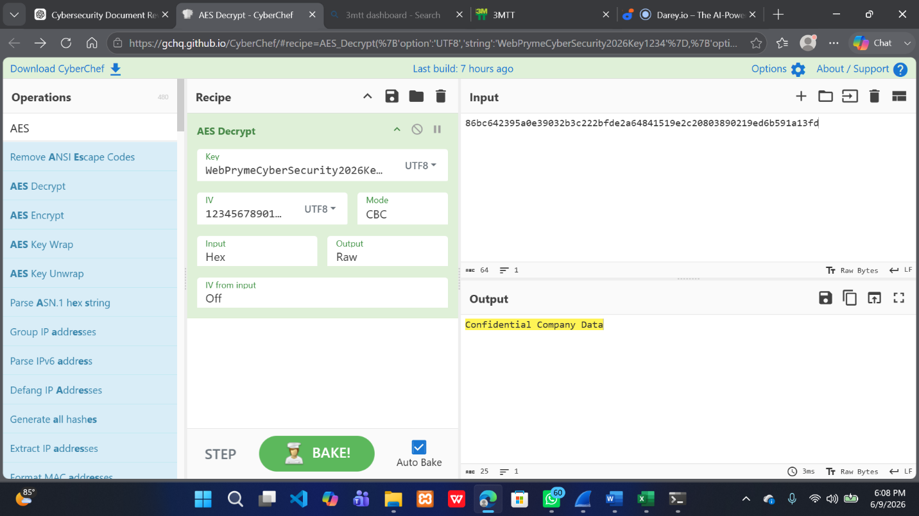
Analysis
The successful recovery of the original message verifies that the encryption and decryption processes were correctly implemented and that the cryptographic parameters were properly configured.

- SECURITY CONSIDERATIONS
Several cybersecurity best practices were demonstrated during this project:
Strong Encryption
AES provides strong protection against unauthorized access.
Key Protection
Encryption keys should never be shared publicly and must be stored securely.
Initialization Vector (IV) Management
IV values should be carefully managed to maintain encryption effectiveness.
Data Confidentiality
Encryption protects sensitive information during transmission and storage.
Access Control
Only authorized individuals possessing the correct key should be allowed to decrypt protected information.

- LESSONS LEARNED
During this project, the following concepts were learned:
• Fundamentals of cryptography • Symmetric encryption principles • AES encryption implementation • Ciphertext generation • Decryption workflows • Importance of encryption keys • Role of initialization vectors • Data confidentiality protection • Practical use of CyberChef in cybersecurity operations

- PROJECT VALIDATION SUMMARY
Task | Status
CyberChef Accessed | PASS
AES Encryption Configured | PASS
Ciphertext Generated | PASS
AES Decryption Configured | PASS
Original Message Restored | PASS
Encryption Workflow Verified | PASS
Overall Project Status: SUCCESSFUL

- CYBERSECURITY SIGNIFICANCE
Encryption is one of the most important cybersecurity controls used to protect sensitive information. Organizations use encryption to secure:
• Financial records • Customer information • Business communications • Cloud storage data • Healthcare records • Government information
This project demonstrates the practical implementation of cryptographic protection mechanisms that are widely used in modern cybersecurity environments.

- CONCLUSION
This project successfully demonstrated the implementation of message encryption and decryption using CyberChef and the AES encryption algorithm. A plaintext message was encrypted into ciphertext and subsequently restored through the decryption process using the same cryptographic parameters.
The project provided practical experience in cryptographic operations, key management, data confidentiality, and secure communication principles. The successful recovery of the original plaintext verified the correctness of the encryption and decryption workflow.
Overall, all project objectives were achieved successfully, and the exercise provided valuable hands-on experience with one of the most important security technologies used in modern cybersecurity.

